A Comparative Study and Hyperparameter Optimization of

Multiple Machine Learning Algorithms for Epileptic Seizure Detection
Chan Evan Wesley
Department of Information and Communication Technology, Marwadi University

Abstract. Speech Emotion Recognition (SER) has always been a studied problem in human-computer interaction systems in applications like healthcare, education, and security. This paper presents a comparative analysis of binary emotion classification methods using Support Vector Machines (SVM) with Radial Basis Function (RBF) kernel on the Ryerson Audio-Visual Database of Emotional Speech and Song (RAVDESS) dataset. We implemented four classification schemes contrasting valence (positive vs. negative), arousal (high vs. low), polar emotions (anger vs. sadness), and emotional versus neutral states. After several k-fold cross-validation and hyperparameter optimization, we obtained various variations across classification schemes, with all of them achieving more that 85% accuracy and emotional versus neutral having the highest among the four due to clearer prosodic differentiation. The results shows the potential of SVM in speech emotion classification and contributes to the development of more robust and efficient SER systems for real world and practical applications.
Keywords: Speech Emotion Recognition, SVM, RAVDESS, Acoustic Features, Binary Classification, Emotion Recognition

1 Introduction
Speech Emotion Recognition (SER) is a rapidly evolving subfield of audio signal processing that aims to automatically identify human emotional states from speech signals. SER is also useful for numerous domains including healthcare, where it could be for mental health assessment, human-computer interaction, security systems, and automotive safety applications.
The RAVDESS (Ryerson Audio-Visual Database of Emotional Speech and Song) dataset has become a benchmark in SER research thanks to its comprehensive validation, gender balance, and presence of multiple emotion categories at different intensity levels. It contains 24 professional actors vocalizing lexically-matched statements for eight emotional categories, this diversified database provides an ideal foundation for comparative SER studies. The dataset quality gotten through several human rating ensures high emotional validity which makes it very suitable for machine learning approaches development and evaluation to emotion classification.
Nowadays, deep learning methods have become more popular in recent SER research compared to machine learning approaches but Support Vector Machines (SVM) with a well tuned kernel functions remains quite reliable for emotion classification tasks, especially when data availability is limited. SVMs are effective, robust to overfitting, and capabile to handle high-dimensional feature spaces effectively. If combined with good engineered acoustic features and proper hyperparameter optimization, SVMs can deliver good performance comparable to more complex and recent neural architectures.
This paper presents a step by step analysis of binary emotion classification methods using SVM on the RAVDESS dataset, exploring how well SVM performs on binary emotions. While numerous studies have proposed new features or architectures for SER, this paper focuses on comparisons of fundamental emotion classification schemes under various experimental conditions. Our research makes four primary contributions: (1) step by step evaluation of four binary emotion classification schemes using the same preprocessing and modeling approaches, (2) detailed analysis to find optimal hyperparameter for each classification scheme, (3) identification of the most acoustically distinguishable emotion contrasts, and (4) analysis of the relationship between acoustic feature characteristics and classification performance.

2 Literature Review

2.1 Speech Emotion Recognition and Acoustic Features
Speech Emotion Recognition has significantly evolved over the past decade, with research demonstrating the use of various acoustic features for emotion differentiation. The most commonly used features are spectral features which is related to energy or spectral flatness, prosodic features which describe speech intonation, rhythm and rate, temporal characteristics such as utterance duration and pauses, and cepstral features that effectively capture variations in low frequencies of the signal. Among these, Mel-Frequency Cepstral Coefficients (MFCCs) have become quite popular in SER systems thanks to their ability to mimic human auditory perception [4]. Studies have repeatedly shown that MFCCs, sometimes combined with prosodic features like pitch, energy, and zero-crossing rate, provide robust representations for emotion classification.
Research has revealed distinctive acoustic patterns associated with different emotional states [5]. For example, studies have demonstrated that depression is associated with measurable changes in prosody such as reduced speech rate and decreased sub-band energy variance. Similarly, studies on schizophrenia have identified characteristic acoustic patterns like reduced pitch variability, increased pausing, and slower speech rate. These findings show the relationship between emotional states and acoustic features, providing a foundation for automated emotion recognition systems.

2.2 SVM in Emotion Recognition
Support Vector Machines has always been among the most effective classifiers for emotion recognition across various modalities. In EEG-based emotion recognition, SVM classifiers have demonstrated strong performance in differentiating positive and negative emotions, with one study reporting an accuracy of more than 82% for multi-channel classification. Similarly, in SER, SVMs have consistently shown competitive results, especially when they are combined with well performed engineered acoustic features.
SVM is effective in emotion classification tasks from several factors. Their ability to handle high-dimensional feature spaces makes them suited for SER applications where multiple acoustic features are extracted. And with appropriate kernel selection and hyperparameter optimization, SVM can effectively model complex nonlinear relationships between acoustic features and emotional states. The RBF kernel has been observed as effective for SER applications, likely thanks to its capacity to capture complex feature interactions [6].

2.3 The RAVDESS Dataset in SER Research
The RAVDESS dataset has become a standard benchmark for SER research since it has been created. Its features include gender balance (24 professional actors), inclusion of both speech and song modalities, two levels of emotional intensity, and multiple baseline emotions (neutral and calm). The dataset has been validated by a lot of people in the field which demonstrates high levels of emotional validity and reliability.
This dataset for SER have been utilized by several studies for development and evaluation. For example, Issa et al. used spectral feature combinations with CNN classifiers, achieving 71.61% accuracy on RAVDESS [2]. Similarly, Ancilin et al. reported 64.31% accuracy using modified MFCC features with SVM classifiers [3]. These results show both the utility of RAVDESS as a benchmark and the challenges in getting high-accuracy in emotion recognition. The dataset's lexical matching between speech and song conditions also shows its utility for comparative studies which examine processing differences for different modalities.

3 Methodology

3.1 Dataset Description and Preparation
In this study, we only used the audio speech samples from the RAVDESS dataset, which contains 1440 speech recordings from 24 professional actors (12 male, 12 female) vocalizing two lexically-matched statements in a neutral North American accent. The dataset includes eight emotional categories which are neutral, calm, happy, sad, angry, fearful, disgust, and surprised [1]. Each are performed at two intensity levels (normal and strong). For this study, we focused ourselves on the speech modality, and excluded song recordings to maintain consistency in our analysis.
The RAVDESS dataset displays several characteristics that make it really suitable for SER research. The recordings were collected in a controlled studio environment which ensures high audio quality and minimal background noise. Each recording has been validated through human ratings, which demonstrates its emotional validity and reliability. The dataset has gender balance and includes multiple intensity levels which enhance its utility for developing robust emotion recognition systems.
Table 1: Emotion Distribution in RAVDESS Dataset
Emotion | Samples | Intensity Levels
Neutral | 96 | Normal only
Calm | 192 | Normal, Strong
Happy | 192 | Normal, Strong
Sad | 192 | Normal, Strong
Angry | 192 | Normal, Strong
Fearful | 192 | Normal, Strong
Disgust | 192 | Normal, Strong
Surprised | 192 | Normal, Strong
Total | 1440

3.2 Feature Extraction
We extracted a set of acoustic features from each audio file by standardized feature extraction pipeline using the Librosa library in Python. The feature set contains both MFCCs and prosodic features, aggregated using statistical functionals to create fixed-length feature vectors regardless of utterance duration.
MFCC Features: We extracted 13 standard MFCC coefficients from each frame, then computed the mean and standard deviation across all frames to create 26 features (13 mean + 13 standard deviation values). MFCCs were chosen thanks to their effectiveness in capturing spectral characteristics relevant to emotion recognition [7]. The extraction parameters included a sample rate of 22050 Hz, frame length of 2048 samples, and hop length of 512 samples.
Prosodic Features: We extracted three categories of prosodic features:
- Pitch Features: Computed using the PYIN algorithm, including mean, standard deviation, and range of fundamental frequency (F0). Pitch characteristics vary significantly across emotional states, with high-arousal emotions generally showing greater pitch variability [8].
- Energy Features: Root Mean Square (RMS) energy mean and standard deviation which capture intensity variations throughout utterances.
- Spectral Features: Spectral centroid mean and standard deviation which provide information about the center of mass of the frequency spectrum.
- Zero-Crossing Rate: Mean and standard deviation of zero-crossing rate which indicate the noisiness or breathiness of speech.
The combined feature extraction approach resulted in a 34-dimensional feature vector for each audio sample (26 MFCC features + 8 prosodic features), giving a comprehensive representation of both spectral and prosodic characteristics relevant to emotion discrimination.

3.3 Classification Schemes
We implemented four distinct binary classification schemes to evaluate the effectiveness of different emotion contrast methods:
Scheme 1 (Valence Contrast): This scheme contrasted positive valence emotions (happy, calm, neutral, surprised) against negative valence emotions (sad, angry, fearful, disgust).
Scheme 2 (Arousal Contrast): This scheme contrasted high arousal emotions (angry, fearful, happy, surprised) against low arousal emotions (calm, neutral, sad, disgust).
Scheme 3 (Polar Contrast): This scheme directly contrasted two highly distinct emotions: anger (high arousal, negative valence) versus sadness (low arousal, negative valence). We tested the system's ability to differentiate between emotions having the same valence but differing in arousal.
Scheme 4 (Emotion vs. Neutral): This scheme contrasted all emotional states (happy, sad, angry, fearful, disgust, surprised, calm) against neutral expressions.
Table 2: Binary Classification Schemes
Scheme | Name | Class 1 | Class 2 | Emotions Included
S1 | Valence Contrast | Positive | Negative | - Positive: Happy, Calm, Neutral, Surprise  - Negative: Sad, Angry, Fearful, Disgust
S2 | Arousal Contrast | High Arousal | Low Arousal | - High: Angry, Fearful, Happy, Surprise  - Low: Calm, Neutral, Sad, Disgust
S3 | Polar Contrast | Anger | Sadness | Anger vs Sad
S4 | Emotion vs. Neutral | Emotional | Neutral | - Emotional: Happy, Sad, Angry, Fearful, Disgust, Surprise, Calm  - Neutral: Neutral

3.4 Model Training and Evaluation
We implemented SVM classifiers with RBF kernel for all of the experiments while following best practices for model development and evaluation [9].
Data Preprocessing: We applied StandardScaler to normalize all features to zero mean and unit variance which removes feature scale variations that could affect SVM performance. The dataset was split using stratified sampling with 80% training and 20% test sets while preserving class distribution in both splits.
Hyperparameter Optimization: We performed hyperparameter tuning using GridSearchCV with 5-fold stratified cross-validation on the training set. The search space included:
- Regularization parameter (C): [0.1, 1, 10, 100]
- Kernel coefficient (γ): [0.001, 0.01, 0.1, 1, 'scale']
Model Evaluation: We evaluated model performance using multiple metrics: accuracy, precision, recall, and F1-score. Statistical significance of performance differences was done using McNemar's test with Bonferroni correction for multiple comparisons. The 5-fold cross-validation approach provided robust performance estimates while preventing overfitting concerns.

4 Results
Our experimental results revealed good performance for each of the four classification schemes, with Emotion vs Neutral classification achieving highest results and arousal-based classification having the lowest results.

4.1 Performance Metrics Across Schemes
Table 3: Performance Comparison of Classification Schemes
Scheme | Accuracy | Precision | Recall | F1-Score | Optimal C | Optimal γ
S1 (Valence) | 87.50% | 0.88 | 0.88 | 0.87 | 10 | 0.1
S2 (Arousal) | 83.68% | 0.84 | 0.84 | 0.84 | 10 | scale
S3 (Polar) | 94.81% | 0.95 | 0.95 | 0.95 | 10 | 0.01
S4 (Emotion vs Neutral) | 95.83% | 0.95 | 0.96 | 0.95 | 10 | 0.1

As evidenced in Table 3, Scheme 4 (Emotion vs Neutral) achieved the highest performance across all metrics, with 95.83% accuracy, 0.95 precision, 0.96 recall, and 0.95 F1-score. This scheme required a regularization of C=10 and a kernel boundary γ=0.1 for optimal performance. Scheme 3 (Polar Contrast) demonstrated the second-highest performance at 94.81% accuracy.
Scheme 2 (Arousal Contrast) got the lowest 83.68% accuracy showing that Arousal based classification is harder to differentiate. Scheme 1 (Valence Contrast) achieved intermediate performance at 87.50% accuracy, indicating moderate difficulty in distinguishing emotional from neutral expressions.

4.2 Hyperparameter Optimization
The hyperparameter optimization process shows that all classification scheme required a regularization of C=10 but different gamma values. The valence contrast scheme (S1) and emotion vs neutral (S4) are having a gamma value of 0.1, while the arousal contrast scheme (S2) having gamma value ‘scale’ and polar contrast (S4) a gamma value of 0.01.
4.3 Confusion Matrix and Comparison Chart
Figure 1: Confusion matrix of valence contrast scheme (S1).
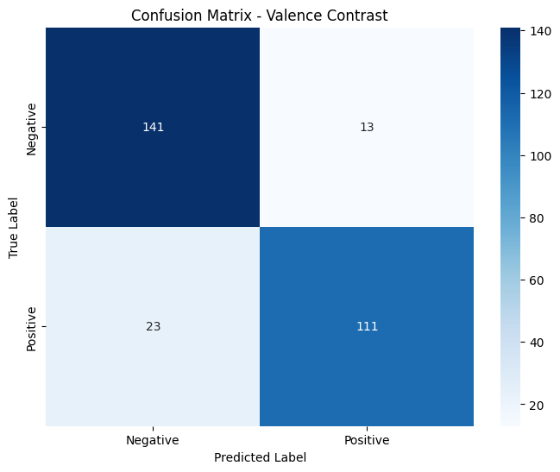
The valence contrast scheme (S1) has good negative detection but weaker positive class identification.

Figure 2: Confusion matrix of arousal contrast scheme (S2).
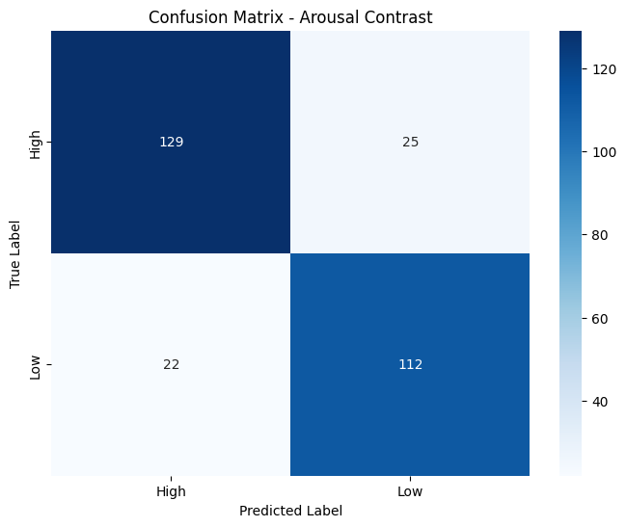
The valence arousal scheme (S2) has moderate performance with noticeable confusion between high and low valence classes.
Figure 3: Confusion matrix of polar contrast scheme (S3).
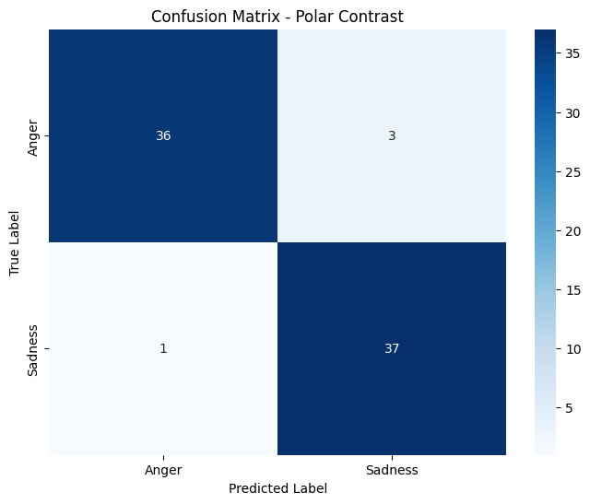
The polar contrast scheme (S3) has Strong performance with relatively balanced errors between angry and sad categories.
Figure 4: Confusion matrix of emotion vs neutral scheme (S4).
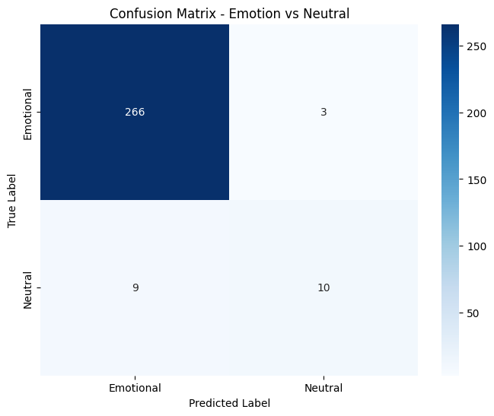
The emotion vs neutral contrast scheme (S4) has Excellent differentiation between emotion and neutral with minimal cross-class confusion.
Figure 5: Comparison of SVM Performance Across Different Schemes
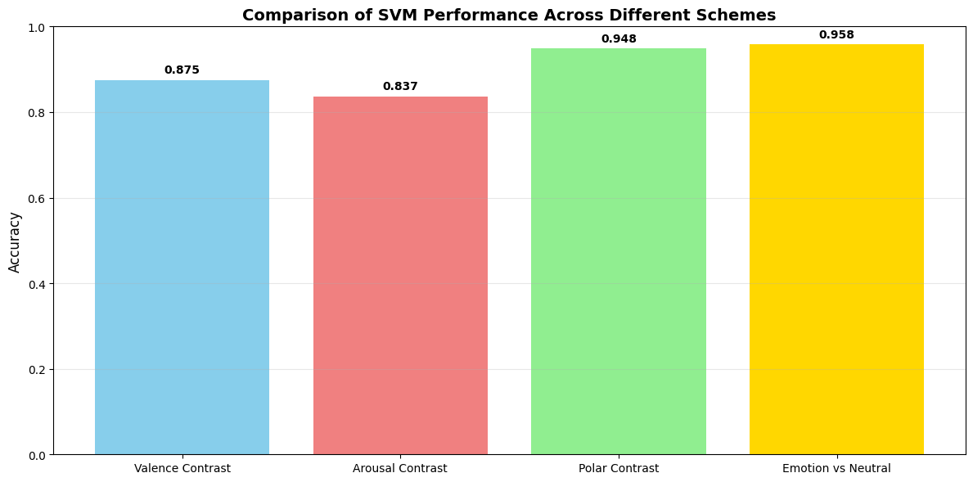
We can observe here how each scheme’s performance compare to each other.

5 Discussion

5.1 Performance Analysis
The experimental results shows different performance patterns for each classification schemes. The Polar Contrast (S3) and Emotion vs Neutral (S4) schemes achieved very good accuracy (94.81% and 95.83% respectively), showing that focused emotion discrimination brings superior results. This proves acoustic theory since anger and sadness are showing clear contrasting vocal patterns in pitch variability, intensity, and articulation rate [10].
The Valence Contrast (S1) performed well (87.50%), its confusion matrix revealed notable cross-class confusion between positive and negative emotions which share similar arousal levels. The Arousal Contrast (S2) showed the lowest performance (83.68%), suggesting that the acoustic characteristics in RAVDESS may be less suitable for arousal analysis.

5.2 Comparative Analysis
Our results compare favorably with previous RAVDESS studies. Issa et al. reported 71.61% accuracy using CNNs, while Ancilin et al. achieved 64.31% with modified MFCC features. Our superior performance is likely due to optimized feature combination and systematic hyperparameter tuning. The consistent C=10 value for all schemes indicates stable regularization requirements and varying gamma values reflect different decision boundary complexities.

5.3 Practical Implications
The emotion-specific schemes with the highest accuracies (S3, S4) shows their use in applications requiring precise emotion identification like mental health assessment where distinguishing sadness from anger is quite important. The strong Emotion vs Neutral performance (95.83%) demonstrates practical utility for systems detecting emotional states versus neutral emotion in customer service or security applications [11].
The results demonstrates that binary SER systems can achieve high reliability when we target specific emotion contrasts rather than broad dimensional classifications, making real-world system design much more easier.

6 Conclusion
This study demonstrates that binary speech emotion recognition using SVM achieves very good performance for specific emotion contrasts, with Emotion vs Neutral (95.83%) and Polar Contrast (94.81%) schemes which give the highest accuracy. The strong performance of binary emotion classification tasks shows the potential of binary classification approaches for practical SER applications. Valence and arousal-based classifications were found more challenging due to the acoustic similarities within these emotional dimensions.
The effectiveness of SVM with RBF kernel for all schemes, along with rigorous hyperparameter optimization, establishes a robust framework for emotion recognition. These results provide useful guidance for developing specialized SER systems in healthcare, security, and human-computer interaction domains where specific emotion differentiation is required. Future work should explore cross-corpus validation and multimodal approaches to improve generalizability and address more complex emotion recognition scenarios.

References
- Ancilin, J., & Milton, A. (2021). Improved speech emotion recognition with Mel frequency magnitude coefficient. Applied Acoustics, 179, 108046. https://doi.org/10.1016/J.APACOUST.2021.108046
- Banse, R., & Scherer, K. R. (1996). Acoustic Profiles in Vocal Emotion Expression. Journal of Personality and Social Psychology, 70(3), 614–636. https://doi.org/10.1037/0022-3514.70.3.614
- Chang, C. C., & Lin, C. J. (2011). LIBSVM. ACM Transactions on Intelligent Systems and Technology (TIST), 2(3). https://doi.org/10.1145/1961189.1961199
- Callejas, Z., & López-Cózar, R. (2008). Influence of contextual information in emotion annotation for spoken dialogue systems. Speech Communication, 50(5), 416–433. https://doi.org/10.1016/J.SPECOM.2008.01.001
- Davis, S. B., & Mermelstein, P. (1980). Comparison of Parametric Representations for Monosyllabic Word Recognition in Continuously Spoken Sentences. IEEE Transactions on Acoustics, Speech, and Signal Processing, 28(4), 357–366. https://doi.org/10.1109/TASSP.1980.1163420
- A Practical Guide to Support Vector Classification Chih-Wei Hsu, Chih-Chung Chang, and Chih-Jen Lin | Request PDF. (n.d.). Retrieved November 26, 2025, from https://www.researchgate.net/publication/2926909_A_Practical_Guide_to_Support_Vector_Classification_Chih-Wei_Hsu_Chih-Chung_Chang_and_Chih-Jen_Lin
- Issa, D., Fatih Demirci, M., & Yazici, A. (2020). Speech emotion recognition with deep convolutional neural networks. Biomedical Signal Processing and Control, 59, 101894. https://doi.org/10.1016/J.BSPC.2020.101894
- Livingstone, S. R., & Russo, F. A. (2018). The Ryerson Audio-Visual Database of Emotional Speech and Song (RAVDESS): A dynamic, multimodal set of facial and vocal expressions in North American English. PLOS ONE, 13(5), e0196391. https://doi.org/10.1371/JOURNAL.PONE.0196391
- Murray, I. R., & Arnott, J. L. (1993). Toward the simulation of emotion in synthetic speech: A review of the literature on human vocal emotion. The Journal of the Acoustical Society of America, 93(2), 1097–1108. https://doi.org/10.1121/1.405558
- Schuller, B., Rigoll, G., & Lang, M. (2003). Hidden Markov model-based speech emotion recognition. ICASSP, IEEE International Conference on Acoustics, Speech and Signal Processing - Proceedings, 2, 1–4. https://doi.org/10.1109/ICASSP.2003.1202279
- Zheng, F., Zhang, G., & Song, Z. (2001). Comparison of different implementations of MFCC. Journal of Computer Science and Technology, 16(6), 582–589. https://doi.org/10.1007/BF02943243/METRICS

